Magic Kingdom

Tony's Restaurant, the Lady and the Tramp penny, has been
replaced by a Lady and Tramp, number 5 of 6 from the Lady and the
Tramp series

Animal Kingdom

penny machine at Disney's Outfitters, Safari Minnie has been
replaced with a coin showing the logo for the Festival of the Lion King Show

penny machine at the Outpost Gift shop, Safari Mickey has been
replaced by Shere Khan, number 6 of 6 from the Jungle Book series

MGM Studios

Celebity 5 & 10, all dies have been replaced:
A. Roger Rabbit in a cartoon car
B. Lady and the Tramp, number 3 of 6 in the Lady and Tramp
series
C. Baloo, number 3 of 6, from the Jungle Book series

Outside the Bear in the Big Blue House show
A. Monsters Boo 4 of 6
B. Monsters Randall 3 of 6
C. Bear Bear 1 of 7
D. Bear Pip & Pop 3 of 7

Sorcerer Hat Shop (might be hard to see)
A. Bear Tutter 6 of 7
B. Monsters Cella 6 of 6
C. Monsters Walternoose 5 of 6
D. Bear Shadow 7 of 7

Epcot

Mission Space

A. Horizontal, Donald, Pluto, Mickey, Minnie and Goofy dressed for space. Wording is "MISSION SPACE 2003". B. Vertical, Mission Space ride logo over the Epcot logo. C. Horizontal, Pluto, Mickey, and minnie dressed for space. Wording is "MISSION SPACE 2003".

Resorts

Port Orleans

Mickey as the Brave Little Tailor of the 75 Years of Mickey series quarters has been placed on stage again. The machine is located at the Port Orleans resort, French Quarter. As you enter the lobby it is to the left near the player piano. Get 5 copies

Animal Kingdom Lodge Arcade
Monsters Mike 1 of 6

Pop Century
Monsters Sully 2 of 6

Grand Floridian resort
penny machine at bus stop, Winnie the Pooh has been replaced
by two siamese cats, number 6 of 6 from the Lady and the
Tramp series

Shades of Green
Attraction Tickey Sales
- Shades of Green Resort Logo
- Shades of Green Navy Logo
- Shades of Green Army Logo

Fantasia Gardens Miniature Golf
Added to the quarter machine, is a new penny machine
A. Mickey as the sorcerer's apprentice
B. Donald Duck with Rays
C. portrait Goofy

Winter/Summerland miniature Golf
A new single die machine has been added, Goofy wearing a
swimming tube

Ft Wilderness Reception Center
A. Bear Ojo 2 of 7
B. Bear Treelo 4 of 7
C. Bear Luna 5 of 7

Ft Wilderness Campgrounds
Gill replaces a die with Meeko

Caribbean Beach Resort, Port Royale
Nemo, replaces a design with Pongo and Perdita

Contemporary Resort
Dory and Marlin,. (The three penny machines have been moved and are in a different order. Pooh series 5 of 7 has been moved from A button of one machine to A button of a second machine. A die of Mickey as an astronaut is brought back to the A button of the first machine and Woody in the A button of the second machine has been retired. Space Minnie has been replaced by the Finding Nemo series 2 of 6.)

All Stars Sports Resort
Dory, replaces a die with Dopey.

Grand Floridian Resort
Pearl, replaces a die with a portrait of Goofy.

Polynesian Resort
lose to Ohanas Restaurant, Bruce replaces a die with Chief Powhatan (Pocahontas movie).

Downtown Disney, Disney Quest
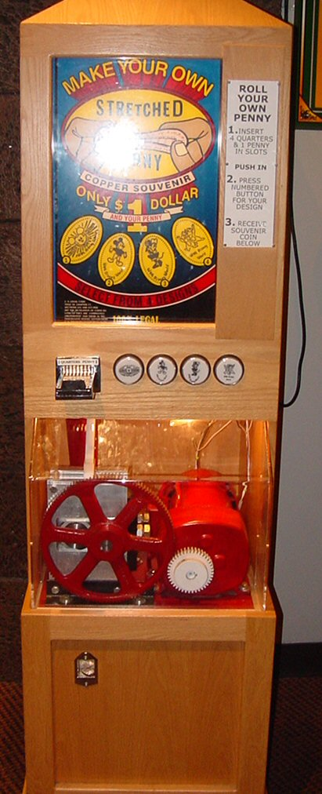

The original penny machine that was at the Main Street Penny Arcade in 994 has been restored to working order: Mickey with rays, Mickey with hands out, Minnie, Chip and Dale

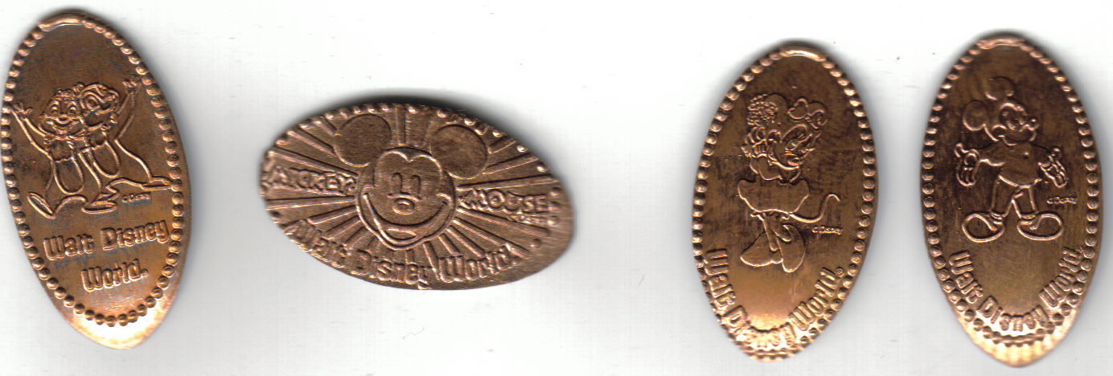

Non-Disney but on site

Rain Forest Cafe at Animal Kingdom

A new 4-die hand-crank machine (all say Orlando, Fl)
A. 2 hot air ballons in flight
B. Mockingbird (state bird of Florida)
C. Cartoon crab with Martini
D. Alligator

Small hallway by bathrooms
- Four Leaf Clover in front of golf ball “My Lucky/Ball Mark”
- Crab on beach chair wearing sunglasses and holding a glass of winr, “FLORIDA/SUNSHINE STATE”
- Orange Blossom “ORANGE BLOSSOM/FLORIDA STATE FLOWER”
- Butterfly “FLORIDA”

